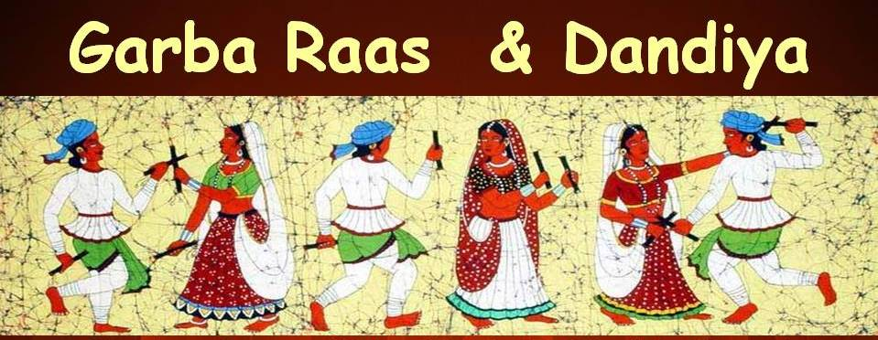

in Lafayette on Durga Ashthami Saturday, October 12, 2013.

5:30 P M Starting with Prayers and Maha Prasad Dinner followed by Garba

Location: Heymann Park Center, 1500 S. Orange Street, Lafayette, LA-70501.

Directions: From I-10, take exit 103 to south I-49 which is Evangeline Thruway. After 2+ miles, take a Left turn on Pinhook road and go 6 blocks, Take Right turn on S. Orange Street, Heymann Center will be on your Left.

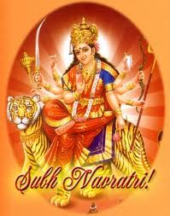 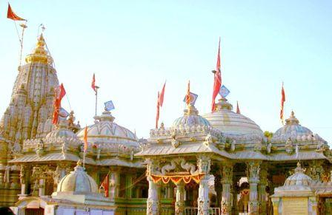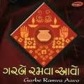

This event is brought to you with the grace of Mataji by:

Gujarati Samaj of South Central Louisiana and

Sanatan Hindu Sanskar Kendra (SHSK).

Garba – Raas – Dandia will be conducted Live by Shree Radha Krushna Mandal

Donors, Current Members of Gujarati Samaj and Sanatan Hindu Sanskar Kendra and children under 10 years of age will enter free of charge. Non-Members please pay $10 per person at the Entrance. Your contribution is payable in cash to the Gujarati Samaj, or by cash, check & credit card to “Sanatan Hindu Sanskar Kendra”. Thanks to generous Donors in advance.

For Additional information, Please contact

Anil Patel…....337-962-1982, Nilesh Patel…...337-344-5862, Vijay Patel…...337-315-0706

Jay Patel……..337-739-2400, Dinesh Deoras….......337-296-6576.

Ambe Maat Ki Jai